EXPERIMENT NO. 2
Host Discovery

Tool Used | Nmap (Network Mapper)

Platform | Kali Linux

Target Host | 192.168.1.1
AIM
To perform host discovery on a target network using Nmap and study the various host discovery techniques available in Kali Linux, such as ping scan, ARP discovery, and DNS resolution control.
TOOLS REQUIRED
- Kali Linux (with Nmap pre-installed)
- A target machine / IP address reachable on the network
- Terminal with root privileges
THEORY
Host discovery is the process of determining whether a target host is online before scanning its ports. Instead of sending probes to every possible port, Nmap first sends discovery packets — such as ICMP echo requests, ARP requests, or TCP/UDP probes — to quickly identify live hosts on a network. Options like -Pn skip this step entirely and assume every host is up, while -sn performs only the discovery step without scanning any ports. ARP-based discovery (-PR) is used automatically on local Ethernet networks since it is faster and more reliable than other probes, and -n can be used to disable DNS resolution for quicker scans.
PROCEDURE
Step 1: Open Nmap from Kali Linux: Applications → Information Gathering → Nmap.
Step 2: Perform different types of scans — TCP, UDP, ACK, SYN, FIN, NULL, XMAS, RPC, Idle — scan types.
Step 3: To perform host discovery, use the flags listed in the table below against the target host.
HOST DISCOVERY OPTIONS
Flag | Use | Example
-Pn | Treat all hosts as online — skip host discovery (port scan only) | nmap -Pn 192.168.1.1
-sn | Ping scan only — host discovery without port scan | nmap -sn 192.168.1.1
-PR | ARP discovery on a local network | nmap -PR 192.168.1.1
-n | Disable DNS resolution | nmap -n 192.168.1.1

Note: -sn is useful for quickly mapping which hosts are alive on a subnet without triggering a full port scan, while -Pn is useful when a host is known to block ping probes but you still want to scan its ports.
OUTPUT
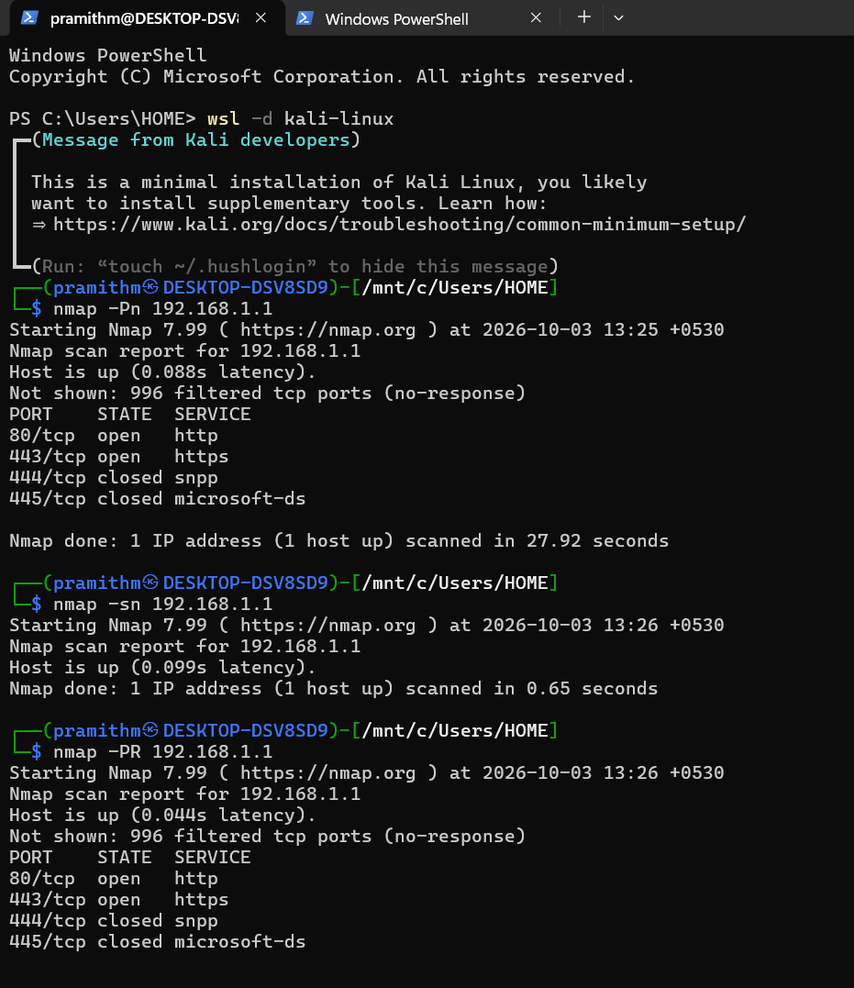
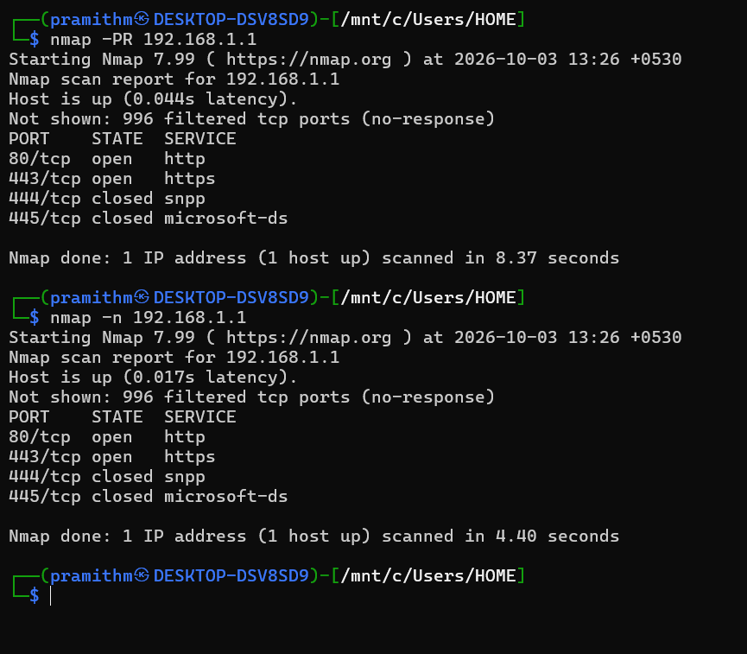

RESULT
Thus, host discovery on the target network was successfully performed using Nmap with the -Pn, -sn, -PR, and -n options, and the live hosts on the network were identified and recorded.

